**Dated:17.07.2019**

**The Convener, UFBU**

**The General Secretaries, Constituents of UFBU**

**IBA’S MEDICAL INSURANCE SCHEME FOR RETIREES**

As you are aware, the Department of Financial Services, Ministry of Finance, Govt of India advised IBA vide its communication dated 24th February 2012 to evolve a Medical Insurance Scheme for serving and retired employees of the Banks. IBA in turn put up this proposal as management issue before UBFU at the time of wage negotiations which concluded in April/May 2015. As a result a new medical insurance scheme got introduced both for serving employees and also for the retired employees with effect from October 2015 for serving employees and November 2015 for retired employees. After introduction of IBA’s Medical Insurance Scheme during the year 2015 there has been multi fold increase in the premium thereby compelling many of the retirees to opt out of this scheme for the reasons of un-affordability, more particularly those who are family pensioners drawing as low as Rs. 4000 per month pension. The entire amount of annual pension in such cases would not be sufficient to meet out the medical insurance premium. The sky rocketing premium has robed many pensioners of the benefit under IBA policy which has been otherwise largely helpful to the retirees. Such situation calls for the improvements/ modifications in the scheme for retired employees. It is with this view in mind the following suggestions are made for kind consideration:

1. Since Government communication dated 24.02.2012 did not envisage payment of medical insurance by the retirees, it should be borne by the Bank as in the case of serving employees. It is pertinent to mention that the Executive Directors/Managing Directors/ Chairman and Managing Directors are extended the benefit of medical expenses reimbursement even after retirement without any charge to them as they were entitled during their service. It is therefore discriminatory on the part of the Banks to create a class within the class with regard to extension of medical benefit facility to retired bank employees vis-à-vis the top retired functionaries of the Bank on one side and the serving employees on the other side. There is an urgent need to improve this unfair practice of treating retired bank employees with discrimination.
2. There should be a common medical insurance policy for serving and retired employees so as to bring down the claim ratio and the resultant annual medical insurance premium.
3. Since all the retirees are senior and super senior citizens, their medical insurance being a social security measure, the payment of the insurance premium and so also the hospitalization bills be brought under 0% slab of GST
4. Medical insurance premium in case of single person be lower than the premium charged for the other retired employees having a surviving spouse.
5. It is also proposed that the retired bank employees of Banks which are instrumentalities of the Government and hence falling within the meaning of State under Article 12 of the Constitution of India should be covered under CGHS after charging a fixed lump sum amount at the time of retirement or at the time of extending the cover to those who have already retired.
6. Alternatively, the medical facility should be extended by the Banks to the retirees through empanelled hospitals against charging a fixed one-time amount towards medical fee for their life time. The fixed sum should be so decided for different slabs of medical cover with an option to the retired employee to choose the medical slab according to his requirement and wish.
7. It is requested that the Retirees should not be discriminated and such medical insurance premium should be paid by the Banks.
8. It is requested to include specially challenged dependent children in the definition of family to provide Medical Insurance benefit.
9. Those members who had opted out of the scheme due to exorbitant amount of premium should be allowed to rejoin the scheme.

We earnestly request you to take up the issues with IBA and make the scheme meaningfully affordable to all the retirees including Family Pensioners.

Thanking you,

Yours Comradely,

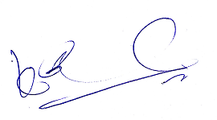 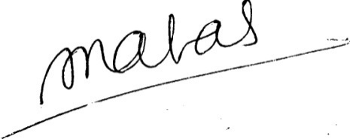

**(K.V. Acharya) (S.C.Jain)**

**Joint Convener, CBPRO General Secretary, AIBRF**