Dated: 18.09.2019

Shri V G Kannan,

Chief Executive,

Indian Banks Association

Mumbai.

Respected Sir,

Sub: **Renewal of Medical Insurance Scheme for Retirees for year 2019-20.**

**Urgent Attention & Consideration Requested.**

We are happy that issues concerning the Bank Retirees are taken up in the ongoing Wage Negotiation Talks between IBA and UFBU. We are very hopeful that resolution of such issues will take place soon.

As Group Medical Insurance Policy for Bank Retirees is due for renewal immediately, we are once again requesting you to consider the following which will help the Retirees to a great extent.

1. Introduction of Multiple slabs in the Medical Insurance Policy to enable the Retirees to opt for the slabs convenient and affordable to them.

2. Reduction of Room rent in case of Hospitalization from Rs5000 to Rs4000.

3. Reduction of Insurance Premium in respect of Single Pensioners, Family Pensioners and those who are getting very meagre ex-gratia (Pre-1986 Retirees).

4. The policy should cover the differently abled children of the Retiree.

5. Enabling those Retirees who opted out of the Scheme in the past due to steep increase in the Premium to opt again for the Group Medical Insurance Scheme which will increase the number of Policy Holders and also increase the collection of Premium.

6. The Banks should be advised to give sizable subsidy in respect of Premium and at least the increased portion of the Premium for the year 2019-20 and the GST component of 18% should be borne by the Banks.

The above are the minimum expectations of the Retirees in respect of the Group Medical Insurance Policy and we request the IBA to consider the same favourably.

With Regards,

Yours Sincerely,

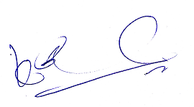 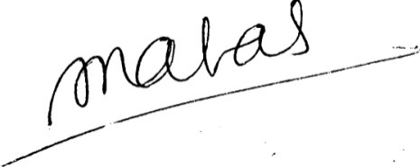

(K V Acharya) (S C Jain)

Joint Convener, CBPRO General Secretary, AIBRF