Dated:29.09.2019

Com. Sanjeev K Bandlish

Convener, UFBU

General Secretary, NCBE

Dear Comrade,

**Sub: Bank Retirees Medical Insurance Scheme 2019-20**

We refer to our letters dated 6th & 9th in regard to the above.

We had addressed/forwarded the above letters to you seeking your help in reducing the Premium to at least some extent by introducing multiple slabs of the Insurance policy amount and also reducing the room rent/bed charges and allowing those who opted out of the scheme due to steep increase in the premium amount to re-enter the scheme for the year 2019-20 and also extending the policy to the Dependent Differently Abled Children and substantial subsidy.

You will appreciate the anxiety of the Bank Retirees due to the exorbitant rise in the premium amount. Our suggestions are in the nature of minimum adjustment in respect of the terms and conditions as the Policy is different to the Retirees and in no way affects the terms and conditions of the serving Employees nor it adversely affects the scheme for the serving Employees and Officers.

While we were hopeful of our suggestions being accepted, Banks have started issuing circulars in regard to the medical scheme for the Retirees without considering our suggestions. However, the time limit given to the Retirees in the Banks circulars to exercise their options extends upto middle of October there is still scope for accommodating the suggestions given by us so that some relief is given to the Bank Retirees.

We seek your urgent attention and intervention in this regard.

Thanking you,

Yours Comradely,

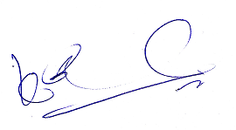 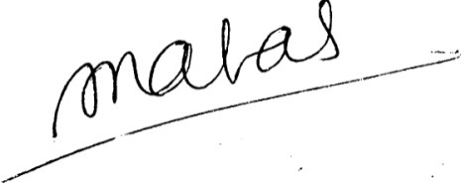

(K V Acharya) (S C Jain)

Joint Convener, CBPRO General Secretary, AIBRF