**ALL INDIA BANK PENSIONERS’ & RETIREES’ CONFEDERATION **

**(A.I.B.P.A.R.C.)**

C/O BANK OF INDIA OFFICERS’ ASSOCIATION

(EASTERN INDIA BRANCHES)

BANK OF INDIA, KOLKATA MAIN BRANCH

23A, NETAJI SUBHAS ROAD, KOLKATA – 700 001

Mobile : 9674188524, E-mail : [aibparc@gmail.com](mailto:aibparc@gmail.com)  **========================================================================**

Circular No.15-20 Date : 07. 02. 2020.

**(For circulation among members of the governing council of AIBPARC,**

**State Secretaries, Special Invitees and Advisors.)**

Dear Comrade,

**Sub: Meeting of Governing Council of AIBPARC to be held at Hyderabad on 30th March,2020.**

Further to our circular no.13-20 dated 05.02.2020, we request all our GC members not to purchase the return tickets on the same day for the following reasons:

As there is a possibility of prolonged discussion on BIPARTITE SETTLEMENTS vis-a-vis the issues of retirees and the completely changed scenario of the Banking sector arising out of proposed merger w.e.f 1st April,2020, the duration of the meeting might be extended by a few hours.

Members are requested to co-operate.

With best wishes,

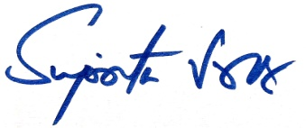

Suprita Sarkar

General Secretary