**ALL INDIA BANK PENSIONERS’ & RETIREES’ CONFEDERATION **

**(A.I.B.P.A.R.C.)**

C/O BANK OF INDIA OFFICERS’ ASSOCIATION

(EASTERN INDIA BRANCHES)

BANK OF INDIA, KOLKATA MAIN BRANCH

23A, NETAJI SUBHAS ROAD, KOLKATA – 700 001

Mobile : 9674188524, E-mail : [aibparc@gmail.com](mailto:aibparc@gmail.com)  **========================================================================**

Circular No.26-20 Date : 02.03.2020.

**(For circulation among members of the governing council of AIBPARC,**

**State Secretaries, Special Invitees and Advisors.)**

Dear Comrade,

**SUB** : **Bipartite Talks with IBA on 29.02.2020**

We reproduce hereunder the text of CBPRO letter dated 02.03.2020 addressed to Chairman, IBA, on above subject for information of members.

With best wishes,

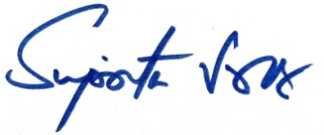

( Suprita Sarkar )

General Secretary

Quote

Dated:02.03.2020

Shri Rajnish Kumar

Chairman

Indian Banks’ Association

Mumbai

Dear Sir,

**Bipartite Talks with IBA on 29.02.2020**

We are glad to learn about the developments in Bipartite talks and hope that under your stewardship the interests of Senior and Super Senior Citizens shall be taken care of by resolving their long pending issues along with the ensuing settlement.

We wish to place on record our appreciation for your kind concern about the pending issues of Bank Pensioners’ & Retirees.

We understand that the improvements in Family Pension will be considered at Par with Central Government and RBI Family Pension Scheme.

As regards Updation of Pension we wish to reiterate that Court Rulings and Regulations provide for the same but its implementation has been eluding us. The progress made during the talks on 29.02.2020 about Updation gives a ray of hope to the aspiring Senior & Super Senior Citizens that Updation of Pension at Par with RBI Pensioners shall benefit 4.50 lakh Pensioners including that of SBI. **It may be appreciated that even during the financial year ended 31st March 2019 the Pension funds of Public Sector Banks including SBI witnessed a net accretion of Rs.11,399.67crores after meeting the obligations on account of payment of Pension and Family Pension**. The cost of Updation though a Statutory Obligation of the Banks which are an instrumentality of the State under Article 12 of the Constitution, shall well be met out from the existing Pension Funds without there being any need for additional provisions if the Updation factors used in case of RBI Pension updation are extended to us.

We request you to help us by getting the Medical Insurance Premium of Retirees absorbed by the Banks as in case of serving employees. It is worth mentioning that the communication of DFS, Government of India dated 24.02.2012 did not make any discrimination while advising IBA to evolve a Medical Insurance Scheme both for serving and retired employees.

We also request you to kindly extend 100% DA Neutralization to Pre - November 2000 Pensioners and Retirees and restore equity in DA Payment along with other Pensioners and Retirees. Number of such section of Retirees have come down hugely due to their Very Old Age and they are suffering from multiple disadvantages like lower DA Rates, Non - Updation of Pension, Age related Health Problems and not being able to cover themselves by IBA Medical Insurance Scheme due to steep increase in Medical Insurance Premium etc. Extension of 100%DA Neutralization to Pre November 2000-Retirees will be a Great gesture to those Retirees.  We urge upon Your Good Self to consider this issue on Humanitarian grounds.

Your pragmatic leadership as a Chairman of not only the largest Bank of the Country but also as the Chairman of IBA has given us hope and confidence that our long pending issues being highly compassionate, emotive and genuine shall get resolved along with the impending wage settlement.

With regards

Yours Sincerely

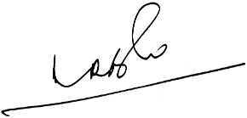 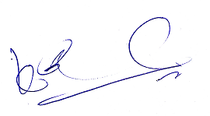

**(A.Ramesh Babu) (K.V. Acharya)**

**Joint Conveners, CBPRO**