**A.Ramesh Babu K.V.Acharya**

**Joint Convener Joint Convener,**

**Flat No 1103, Block 3B, J-208 Vijay Rattan Vihar,**

**S.M.R. Vinay Fountainhead, Sector 15, Part II,**

**Culvary Temple Road, Gurugram -122001**

**Hyderabad 500 049 E-mail: acharyavedavyasa46@gmail.com**

**E-mail:** [**babu2609@gmail.com**](mailto:babu2609@gmail.com) **Mobile: 09868220338**

**Mobile: 09849381995**

**__________________________________________________________________________________** CBPRO Circular 002/2020 Dated:23.07.2020

Dear Comrades,

**11th Bi - Partite Settlement- MOU signed between IBA and UFBU**

We are immensely pleased to know that the much-awaited resumption of Wage Talks has resulted in very positive developments by signing the MOU with 15 percent hike in wages and other understandings with a decision of concluding the settlement with all details within 90 days from the date of signing the MOU.

We heartily Congratulate the entire Leadership of UFBU for this achievement and Thank IBA and the Ministry of Finance, Government of India for facilitating the MOU.

**The one Major satisfaction for Bank Pensioners and Retirees is the information given to UFBU Team by the Chairman of IBA that Improvement in Family Pension at 30 % without any capping on the lines of Government India Employees Family Pension is agreed to.**  This is one very important issue raised by Retirees Organisations which was eluding resolution in spite of repeated assurances. This was also mentioned in the Record note during the last settlement explaining the same as an emotional issue concerning vast number of very aged Family Pensioners and Women Spouses of Deceased Pensioners. **We profusely Thank UFBU Leadership and IBA and the Ministry of Finance for acceding to our request.**

Dear Comrades, other Major issues like Updation of Pension, Medical Insurance Scheme, 100% DA NEUTRALIZATION to Pre November 2002Retirees, Special Allowance component and Grievances will be seriously followed up by us and we are very hopeful of resolution of the issues along with the Settlement. We have the Good Wishes and Support of UFBU with us and at the same time the Determination with which we have been following up the issues despite earlier setbacks is making us feel Confident of resolving our issues.

**Dear Comrades, we are on the Right Path. Success shall be Ours. Let Us Move Together to Get Justice**.

With Warm Regards,

Yours Comradely,

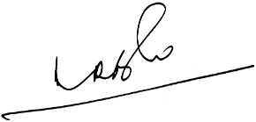 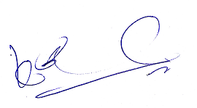

**(A.Ramesh Babu) (K.V. Acharya)**

**Joint Conveners, CBPRO**