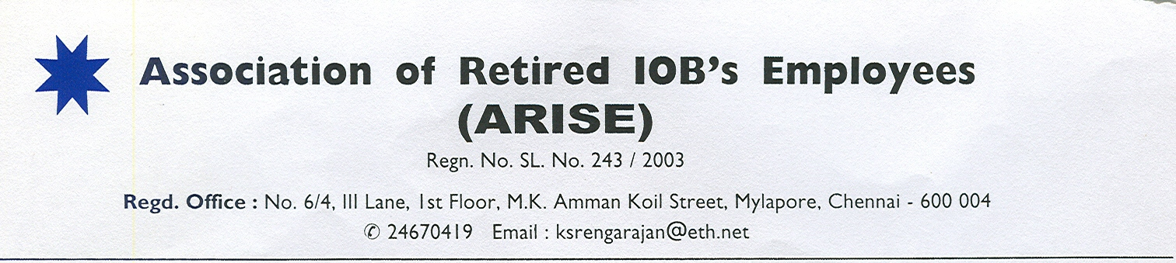**29th September,2021**

**To**

**The Managing Director & CEO,**

**Indian Overseas Bank,**

**Central Office.**

**Dear Sir,**

**Sub: Subsidizing Medical Insurance Premium to Retirees**

At the outset our **hearty congratulations** to you and to all IOBIANs who made it possible for our dear bank IOB to come out of PCAF. The euphoria is sure to elevate the morale of the IOBIANs to double their efforts to restore the lost glory to IOB. While we wish you all the very best, we pledge the whole-heated support of all the retirees of IOB to your endeavour. We have our own issues to be addressed at the bank and industry level but they never detract us from our commitment to stand by our bank at all times.

While we the retirees too rejoice that IOB has come out of PCAF it has also raised hopes among the retirees that the bank will now address the long pending issue of health insurance which is matter of life and death in many instances. The retirees are really depressed on coming to know that there is another steep hike of more than 40% in IBA administered Health Insurance premium that will force still more retirees to resign to the ill-fate of going uninsured. **Out of 20000 plus retirees/family pensioners only about 8000 are presently insured.** This pathetic ratio of insured is due to the continuous steep increase in health insurance premium year after year that has to be fully borne by the retirees. In fact, the IBA administered health insurance scheme’s premium that stood at Rs.7000 at the time of its introduction in the wake of 10th Bipartite Settlement stands now in the wake of 11th Bipartite Settlement at about Rs. 44000 for base policy and Rs. 55000 with super top-up for the highest aggregate cover of Rs.9,00,000). **The base policy alone has witnessed a steep increase of more than 600% in just one settlement period.** The high claim ratio advanced as a reason for repeated hikes is mainly because the number of insured has been shrinking year after year impacting adversely the risk spread to the insurance company. *This shrinkage should cause concern among banks too that their own retirees who sweated for the welfare of the banks had to resign to the ill-fate of having to go uninsured because the health insurance premium eroding their pension substantially was beyond their means.*

In fact, consequent upon IBA administered Health Insurance Scheme, an agreement was reached in our bank to restructure Retirees Medical Assistance Scheme (REMAS) inviting membership from past retirees who were not members and our assuring to mobilize future retirees to join the scheme by contributing to the corpus to which bank will also contribute to subsidize the insurance premium. **It was agreed to commence initially with a subsidy of 50% of the premium towards IBA administered Health Insurance Scheme in lieu of then existing benefits of cash relief of Rs.2000 per annum and group health insurance cover in tie up with Universal Sompo Insurance Co. Ltd.**. Unfortunately the bank running into rough weather impacted the operation of REMAS too and the bank could not subsidize the insurance premium after the first one year but the bank gave cash relief of Rs.2000 alone for a year which was also stopped thereafter. As such, the *retirees are getting neither the benefit that existed before the IBA administered Health insurance scheme nor the agreed benefit under restructured REMAS which is kept under suspension as of now*.

Under the above circumstances, we request you to take a humanitarian view of the whole issue as health is vital for us to lead a life of dignity without being a burden to others and to the society. Now that the bank has started making profits, the bank can take a sympathetic view of ***our request and consider restoring the subsidy to Health insurance scheme partly if not fully for the time being*** ***and extend interest free loan to cover the balance cost of premium***. Your kind gesture will go a long way in bringing relief to all retirees. We earnestly look forward to and thank you in anticipation of a positive response to our request.

Our best wishes to you and your team to make IOB scale greater heights.

**With Regards,**

**Yours faithfully**

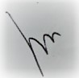 

**S.B.C.Karunakaran K.S.Rengarajan**

General Secretary President